**Problem Statement**

Objective: To identify key customer segments that drive bike sales and to determine whether developing an e-commerce platform can further enhance revenue.

**Challenges:**

1. Segment Identification: With diverse customer demographics, it is challenging to pinpoint which segments contribute the most to revenue and have the highest growth potential.
2. Revenue Enhancement: Understanding which customer segments should be prioritized in marketing and product development to increase overall sales.
3. E-Commerce Viability: Assessing the potential for developing an e-commerce platform to cater to customer preferences and expand market reach, especially for those who may prefer online shopping due to distance or convenience.

**Goal:**

To analyze the dashboard data to identify high-potential customer segments and evaluate the feasibility of an e-commerce platform, aiming to drive targeted marketing strategies and revenue growth.

**Build Dashboard Or a Report:**

Data visualization for the data analysis (DAX) was done in Microsoft Power BI Desktop:

Shows visualizations from Sales insights :

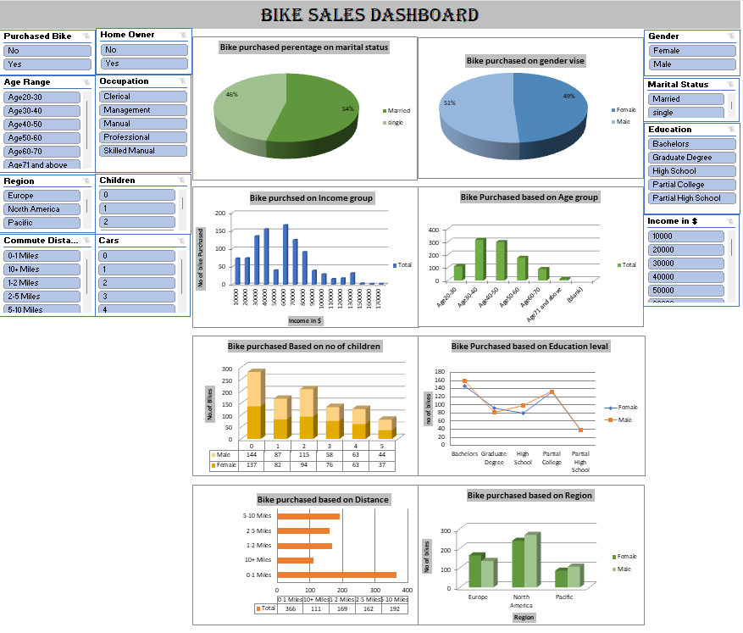

**Tools, Software and Libraries :**

1.Microsoft Excel Pivot table